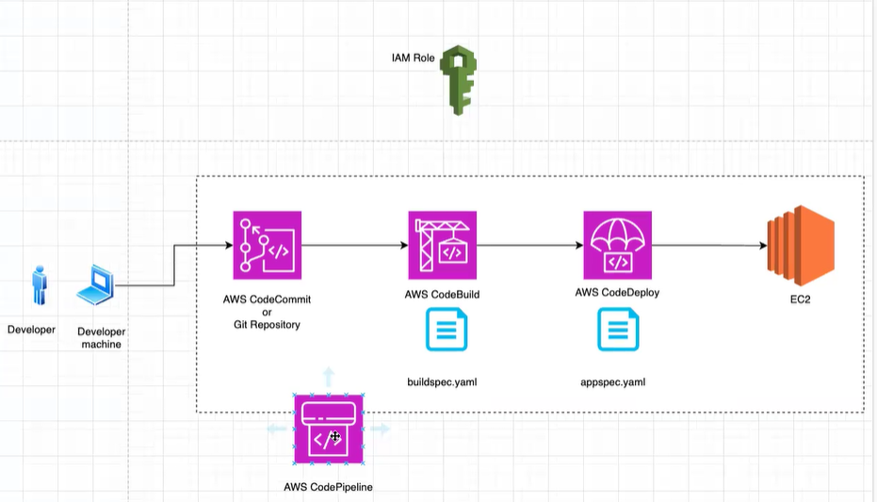

Step 1 – Create a GIT repo

Step 2 – Go to developer machine – clone the Git repository git clone repo url

Step 3 – develop an application

Open Git

Git config --gloabal